My Lesson plan :

1 . Introduction to spring – security

2 . Explaining about : protection between two websites

3 . Explaining what OAuth2 looks like

4 . Explaining all roles in OAuth2 Flow :

1 . Resource owner

2 . Client

3 . Authorization Server

4 . Protected Resource

With picture that are given below :

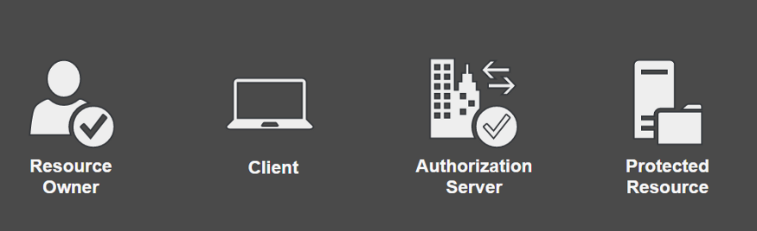

5 . ReExplaining section – 4 and explaining picture in the next page =>

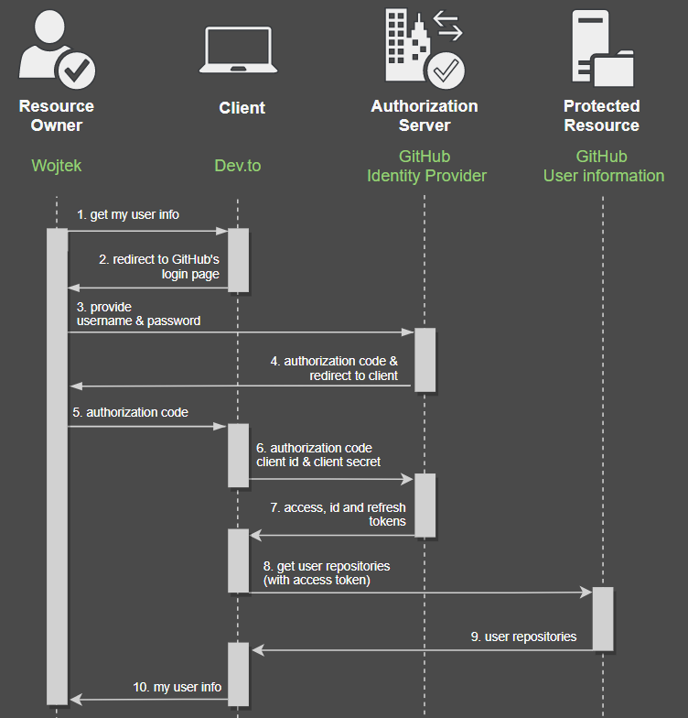

6 . Some details with code

7 . Explaining what is : Access token and Jwt

8 . Explaining what is : Refresh token with picture given below : 